,,Caius Iacob” Conference on
Fluid Mechanics&Technical Applications
Bucharest, Romania, November 2005

KINEMATICS’ DYNAMICAL SYSTEM OF STEADY FLIGHT,
having solutions in implicit form as sin (x(t))=f(t)

Sorin Stefan Radnef,

The main goal of the paper is to find the solution of the dynamical system that represents the kinematics of steady flight, with respect to the flight path, expressed as continuous closed form functions. Flight kinematics represented as aircraft kinematics relative to Serret-Frenet axes system, followed by the kinematics of this axes system relative to the Earth, provides the kinematics’ differential system of the steady flight relative to aircraft trajectory, named “extended steady flight”. Stating the starting values for the kinematics variables and common assumptions regarding the differential system, the solution of this system may be found by numerical methods or as an implicit trigonometric equation, sin(x(t))=f(t) . Having in mind the uniqueness of this solution, we have derived a method to construct the analytical closed form of the function with values x(t), comparing the variations’ properties for the function x(t) relative to those for the function f(t). Finally the numerical values of the function x(t), corresponding to the kinematics variables, and the analytical ones are compared to verify this continuous closed form function. Analytical solution, x(t), requires the zero values for the derivative of f(t) and sign establishment for the derivative of x(t), using a recurrence formula, to derive the values of a specific function named “residual function” in a recurrent manner too.

Introduction
The paper is based on an earlier one presented at AIAA Conference, [1], which emphasizes how the new mechanical model of dynamics for aircraft flight relative to its own trajectory, presented for the first time in reference [2] and then developed in [5], relieves a more realistic steady state flight properties, having a separate dynamical system for the kinematics with respect to Frenet frame. The steady state of a mechanical movement is defined with respect to a specified reference frame (having attached a proper coordinate system with its own axes system) by the unchanged values of its kinematics variables. For the aircraft flight the airstreams flow around him determines the particular features of its movement as a mechanical one. Considering also the dynamics behavior that put into evidence a slow rotation characteristics for the aircraft mass center motion and a (possible) fast motion around the mass center, by side of the prominent part of trajectory characteristics for the performance, control and flight mission requirements, we derive that the kinematics along the trajectory (that is a translation along the flight path) and the kinematics relative to the trajectory (that is relative to the Serret-Frenet frame) must be emphasized and regarded as the two components of the aircraft kinematics. The development of such a view point was done in [5] and [1] and this kinematics representation of the aircraft movement relative to the specified reference frame is able to overcome the contradictions of the common steady state of the aircraft mechanical movement, discussed in reference [4] and denoted as "aerodynamic steady state". Owing to the kinematic emphasizing of the motion relative to flight trajectory, along and relative to the flight path, the mathematical model for flight mechanics, [5], [2], is able to support the steady state conditions relative to the air stream:
$${{\begin{aligned}\overset{˙}{v}=0\text{ m}⋅{\text{sec}}^{\text{-1}}\text{velocity along flight path} \\ {\overset{˙}{ω}}_{a}^{1}=0{\text{ sec}}^{\text{-1}}\text{ , \{}\overset{˙}{ω}\end{aligned}}_{a}^{2}=0{\text{ sec}}^{\text{-1}}\text{ , \{}\overset{˙}{ω}}_{a}^{3}=0{\text{ sec}}^{\text{-1}}\text{angular velocity relative to Serret-Frenet axes}$$
that describe an extensive class of steady states witch may be named as "steady state relative to the air stream", including all the common known ones.
These new steady state flights belong to a more extended class of flights: those having a programmed dynamics of kinematics variables. The steady flight and this class of flight movements may be managed in the same manner using the mentioned flight dynamics model as primary model to solve this type of "inverse problem of aircraft motion", denoted (IPAM), concerning the finding of control laws that steers the aircraft flight having prescribed restrictions for kinematics state variables.

Mathematical Model
Considering “flat Earth approximation” model of flight mechanics, the kinematics equations for the two components of the aircraft motion are, [5], [2]:

$\overset{˙}{χ}=Π_{a}⋅ω_{a}$
$\overset{˙}{σ}=Π_{f}⋅ω_{f}$ (1)
$Σ_{E}=R_{{}^{\text{FO}}}^{T}v$

where we have denoted the matrix and vectors as follows:
χ=[ϕ β α]_{T} rotation angles of aircraft body relative to the Serret-Frenet axes, that is to the trajectory frame (se appendix 2)
σf=[ψf θf ϕf]_{T} rotation angles of the Serret-Frenet axes relative to the Earth frame (see appendic 3)
Ξ_{E}=[X_{E} Y_{E} Z_{E}]_{T} cartesian coordinates
v=[v 0 0]^{T} velocity of mass center in Serret-Frenet axes

$Π_{a}=\left[\begin{matrix}{\text{cos}}^{−1}β⋅\text{cos}α & 0 & {\text{cos}}^{−1}β⋅\text{sin}α \\ \text{sin}α & 0 & −\text{cos}α \\ −\text{tan}β⋅\text{cos}α & 1 & −\text{tan}β⋅\text{sin}α\end{matrix}\right]$ correlative matrix for rotation around the trajectory
$Π_{f}=\left[\begin{matrix}0 & −{\text{cos}}^{−1}θ_{f}⋅\text{cos}ϕ_{f} & {\text{cos}}^{−1}θ_{f}⋅\text{sin}ϕ_{f} \\ 0 & \text{sin}ϕ_{f} & \text{cos}ϕ_{f} \\ 1 & \text{tan}θ_{f}⋅\text{cos}ϕ_{f} & \text{tan}θ_{f}⋅\text{sin}ϕ_{f}\end{matrix}\right]$ correlative matrix for rotation of Serret-Frenet axes

$R_{\text{FO}}={\left[\begin{matrix}\text{ sin}ψ\text{cos}θ & \text{ cos}ψ\text{cos}θ & \text{ sin}θ \\ \text{-sin}ψ\text{sin}θ\text{cos}ϕ\text{+cos}ψ\text{sin}ϕ & \text{-cos}ψ\text{sin}θ\text{cos}ϕ\text{-sin}ψ\text{sin}ϕ & \text{ cos}θ\text{cos}ϕ \\ \text{ sin}ψ\text{sin}θ\text{sin}ϕ\text{+cos}ψ\text{cos}ϕ & \text{ cos}ψ\text{sin}θ\text{sin}ϕ\text{-sin}ψ\text{cos}ϕ & \text{-cos}θ\text{sin}ϕ\end{matrix}\right]}_{f}$
transformation matrix for ro-tation of the Serret-Frenet axes relative to the Earth frame

The equations:

$\overset{˙}{χ}=Π_{a}⋅ω_{a}$ (1_{d})

may be treated separately, becoming the kinematics’ dynamical (sub)system for steady flight, and for extended steady flight they can be integrated in closed form. To do this, one can remark that:

where we have denoted by the low indices (B) and (F) the fact that time derivative are determined in “Body axes”, [4], and in Serret-Frenet axes. These algebraic equations put into evidence, for steady state flight, two independent general integrals for (1_{d}):
having denoted with italic letters the components in Serret-Frenet axes. To use these general integrals it is necessary to consider the differential equations for ω_{a} with components in Frenet frame. An other way to obtain such integrals is to find an integrating factor for the Pfaff forms associated to the differential system. From the above equations we can derive the differential equation for β, expressing sinϕ and cosϕ as functions of sinβ :
, or, considering the formula (8) having k with its specific analytic expression:

(2)

where we have denoted by r_{ϕ}( . ) the values of a function to be determined so to obtain a single valued function for the values of ϕ angle (see the next chapter).

where we have done the following notations:
,
So, we arrive at the following differential system:

(3)

For β we can “separate the variables” and we get:
Naming we may rearrange the formula to put in evidence the invariant term:
(4)
Hence the final formula for sideslip angle:

(5)

Now we remark that the differential equation for α in (3) is quite similar to that for ϕ angle. So, we expect the solution similar to (2). To obtain it we will use the two first integrals specified above. Considering the preceding notations and formulas we get:
or:

(6)

When the formulas (2), (6) are no longer valid, but (3) is still valuable and it states constant attitude angles relative to trajectory.

Continuous closed form solution for fundamental trigonometric equation
Many closed form solutions of technical or scientific interest are obtained as solutions of the fundamental trigonometric equation:
$\text{sin}(x)=f(t)$ (7)
where: $f∈C^{1}(R,[−1,+1])$
$x(t_{0})=x_{0}$ with the compatibility condition $\text{sin}(x_{0})=f(t_{0})$

Our goal is to find the x solution of this equation, pertaining to the class $C^{1}(R,R)$ and being expressed in a closed analytical form. The analyse strategy is to follow the values of x according to the values of f(t) starting from the point (x₀, t₀) and see how the value of k changes in the general formula of the equation solution
$x(t)=(−1)^{k}⋅a\text{sin}[f(t)]+k⋅π$ (8)
It is obvious that if $|f(t)|<1$the value of k remains unchanged. The first value of k, denoted k₀, is the solution of the equation:
$x_{0}=(−1)^{k_{0}}a\text{sin}[f(t_{0})]+k_{0}π$ (9)
For the values |f(t)|=1 the following lemma states that the value of k changes.

Basic Results
Inertia Lemma. The derivative $\frac{d}{\text{dt}}x(t)$ is not zero for the values of t corresponding to the extreme values of f(t).
Proof. Let be f(t1)=+1 and $\frac{d^{2}}{{\text{dt}}^{2}}f(t_{1})<0$. Because +1 is an extreme value of f it becomes that . Considering $x∈C^{1}(R,R)$it follows that the limit $\underset{t→t_{1}}{\text{lim}}\frac{d}{\text{dt}}x(t)$exists and is finite, (is denoted by $\frac{\text{dx}(t_{1})}{\text{dt}}$), that is the limit $\underset{t→t_{1}}{\text{lim}}\frac{\frac{\text{df}(t)}{\text{dt}}}{\sqrt{1−f^{2}(t)}}$ exists and is finite, because

$\underset{t→t_{1}}{\text{lim}}\frac{\text{dx}(t)}{\text{dt}}=\underset{t→t_{1}}{\text{lim}}\frac{\frac{\text{df}(t)}{\text{dt}}}{\text{cos}[x(t)]}=\underset{t→t_{1}}{\text{lim}}\frac{\frac{\text{df}(t)}{\text{dt}}}{\text{sgn}\left[\frac{\text{dx}(t)}{\text{dt}}\right]⋅\sqrt{1−f^{2}(t)}}=\text{sgn}\left[\frac{\text{dx}(t)}{\text{dt}}\right]⋅\underset{t→t_{1}}{\text{lim}}\frac{\frac{\text{df}(t)}{\text{dt}}}{\sqrt{1−f^{2}(t)}}$

Now, according to l’ Hospital rule (theorem) concerning the indefinite limit case $00$, we get:

$\begin{aligned}\underset{t→t_{1}}{\text{lim}}\frac{\text{dx}(t)}{\text{dt}}=\text{sgn}\left[\frac{\text{dx}(t)}{\text{dt}}\right]⋅\underset{t→t_{1}}{\text{lim}}\frac{\frac{\text{df}(t)}{\text{dt}}}{\sqrt{1−f^{2}(t)}}=\text{sgn}\left[\frac{\text{dx}(t)}{\text{dt}}\right]⋅\underset{t→t_{1}}{\text{lim}}\frac{\frac{d^{2}f(t)}{{\text{dt}}^{2}}}{−\text{sgn}\left[\frac{\text{dx}(t)}{\text{dt}}\right]⋅\frac{f(t)⋅\frac{\text{df}(t)}{\text{dt}}}{\sqrt{1−f^{2}(t)}}}= \\ =−\underset{t→t_{1}}{\text{lim}}\frac{\frac{d^{2}f(t)}{{\text{dt}}^{2}}}{f(t)}⋅\frac{1}{\frac{\frac{\text{df}(t)}{\text{dt}}}{\sqrt{1−f^{2}(t)}}}\end{aligned}$

and tacking into account that the limits $\underset{t→t_{1}}{\text{lim}}\frac{\frac{\text{df}(t)}{\text{dt}}}{\sqrt{1−f^{2}(t)}}$ and exist and are finite, the result is:

$\frac{\text{dx}(t_{1})}{\text{dt}}=−\underset{t→t_{1}}{\text{lim}}\frac{\frac{d^{2}f(t)}{{\text{dt}}^{2}}}{f(t)}\frac{1}{\frac{\frac{\text{df}(t)}{\text{dt}}}{\sqrt{1−f^{2}(t)}}}=−\underset{t→t_{1}}{\text{lim}}\frac{\frac{d^{2}f(t)}{{\text{dt}}^{2}}}{f(t)}\frac{1}{\underset{t→t_{1}}{\text{lim}}\frac{\frac{\text{df}(t)}{\text{dt}}}{\sqrt{1−f^{2}(t)}}}=−\frac{\frac{d^{2}f(t_{1})}{{\text{dt}}^{2}}}{f(t_{1})}\frac{1}{\frac{\text{dx}(t_{1})}{\text{dt}}}$

We derive that:
${\left[\frac{\text{dx}(t_{1})}{\text{dt}}\right]}^{2}=−\frac{d^{2}f(t_{1})}{{\text{dt}}^{2}}≠0$ (10)
For f(t-1)=-1 and $\frac{d^{2}}{{\text{dt}}^{2}}f(t_{1})>0$ the proof procedure is of the same type.

Now we will try to determine the number k of the general formula (8) as function of t, tacking into account this lemma and analyzing the various situations that occur when f(t) passes through the values +1 or -1. We will denote this number rf(t), “residual function of f”.
The first result of such a "following analysis" is :
Primary Lemma. At any time t and for any length of time τ
$\begin{aligned}\sum_{|f(t+τ_{k})|=1}{}0<τ_{k}<τ\end{aligned}$
where: $r_{f}(t_{0})$ is the solution of the equation
$x_{0}=(−1)^{r_{f}(t_{0})}⋅a\text{sin}[f(t_{0})]+r_{f}(t_{0})⋅π$ (11)

Proof. The result is obvious by considering the following diagrams for
$\frac{\text{dx}(t+τ_{k})}{\text{dt}}>0$ $\frac{\text{dx}(t+τ_{k})}{\text{dt}}<0$

$r_{f}(t+τ_{k}+ε)=r_{f}(t+τ_{k−1})+1$ $r_{f}(t+τ_{k}+ε)=r_{f}(t+τ_{k−1})−1$

Because we did not know the function x(t) it is necessary to provide a recurrence formula for $\frac{\text{dx}(t)}{\text{dt}}$, concerning the values of f(t) and $r_{f}(t_{0})$.
Recurrence Lemma. At any time t the following formula is true:
$\text{sgn}[\frac{\text{dx}(t+τ_{k})}{\text{dt}}]=−[f(t+τ_{k−1})⋅f(t+τ_{k})]⋅\text{sgn}[\frac{\text{dx}(t+τ_{k−1})}{\text{dt}}]$ (12)

Proof. We may separate four situations regarding time rates of f(t), x(t) and two successive extremes of f(t):

$\begin{aligned}f(t+τ_{k−1})⋅f(t+τ_{k})>0 \\ \frac{\text{dx}(t+τ_{k−1})}{\text{dt}}⋅\frac{\text{dx}(t+τ_{k})}{\text{dt}}<0\end{aligned}$

$\begin{aligned}f(t+τ_{k−1})⋅f(t+τ_{k})<0 \\ \frac{\text{dx}(t+τ_{k−1})}{\text{dt}}⋅\frac{\text{dx}(t+τ_{k})}{\text{dt}}>0\end{aligned}$

These relationships prove the validity of the recurrence formula.

Final result
The relationship between $\frac{\text{dx}(t)}{\text{dt}}$ , $\frac{\text{df}(t)}{\text{dt}}$ and tacke into account the following diagram

that emphasises four cases concerning the signs of the derivatives mentioned above:
rf even and $\frac{\text{df}(t+τ_{k})}{\text{dt}}>0$ ⇒ $\frac{\text{dx}(t+τ_{k})}{\text{dt}}>0$
rf even and $\frac{\text{df}(t+τ_{k})}{\text{dt}}<0$ ⇒ $\frac{\text{dx}(t+τ_{k})}{\text{dt}}<0$
rf odd and $\frac{\text{df}(t+τ_{k})}{\text{dt}}>0$ ⇒ $\frac{\text{dx}(t+τ_{k})}{\text{dt}}<0$
rf odd and $\frac{\text{df}(t+τ_{k})}{\text{dt}}<0$ ⇒ $\frac{\text{dx}(t+τ_{k})}{\text{dt}}>0$

Accordingly, we may derive the following
Signs Lemma. At ant time t and for any τk the following relationship is true:
$\text{sgn}[\frac{\text{dx}(t+τ_{k})}{\text{dt}}]=−\text{sgn}[\frac{\text{df}(t+τ_{k})}{\text{dt}}]⋅\text{sgn}[r_{f}(t+τ_{k−1})−2⋅\left[\frac{r_{f}(t+τ_{k−1})}{2}\right]−\frac{1}{2}]$ (13)

Now we may determine the sign of $\frac{\text{dx}(t+τ_{0})}{\text{dt}}$ :
$\text{sgn}[\frac{\text{dx}(t+τ_{0})}{\text{dt}}]=−\text{sgn}[\frac{\text{df}(t+τ_{0})}{\text{dt}}]⋅\text{sgn}[r_{f}(t_{0})−2⋅\left[\frac{r_{f}(t_{0})}{2}\right]−\frac{1}{2}]$ (14)

and we may determine the final formula for $r_{f}(t+τ)$ .
Theorem. The recurrence formula for $r_{f}(t)$ is:
$\begin{aligned}\sum_{|f(t+τ_{k})|=1}{}0<τ_{k}<τ\end{aligned}f(t+τ_{0})⋅\text{sgn}[\frac{\text{dx}(t+τ_{0})}{\text{dt}}]$ (15)
where: $τ_{0}=\underset{|f(t−ς)|=1}{\text{min}}(ς>0)$
Proof. Using the recurrence lemma we may state the relationship:
$\text{sgn}[\frac{\text{dx}(t+τ_{k})}{\text{dt}}]=(−1)^{k}⋅f(t+τ_{k})⋅f(t+τ_{0})⋅\frac{\text{dx}(t+τ_{0})}{\text{dt}}$
by a simple mathematical induction. Replacing this algebraic expression in the formula of primary lemma and separating the common factor $f(t+τ_{0})⋅\frac{\text{dx}(t+τ_{0})}{\text{dt}}$ we derive the theorem' s formula.

Conclusions

Using the formulae (2), (5), (6) it is possible to take advantages for aircraft kinematics/ dynamics analysis. So, we may done the following

Kinematic discussion
All the preceding formulae presume that:
(16)
, involving physical (kinematics) limits for sideslip angle. These are found by solving the second order algebraic inequalities having sinβ as unknown: . The two roots of the corresponding equation are:
and are, in fact, the two boundaries for sinβ. The formula (11) fulfills these limits:
, or:
and by simple calculations,
Selecting the values of l, m we can state the behaviour of β.
By means of formulas (2), (5), (6) and of system (3) one may analyse the requirements, limitations and type variation that must support the attitude angles χ regarding normal flight conditions. For example:
a₁) , as small as it may be
a₂) ,
a₃) decision criteria upon uniform variation of angles when reaching the boundaries of principal determination for trigonometric functions
The first requirement implies the inequalities:
that are accomplished iff (l+m≠0 and l-m≠0). Hence the requirement to choose, or the conclusion that is possible as ω_{a} one with l+m≠0 and l-m≠0, to achieve an usual flight.
A necessary condition for (a₂) is the existence of α(t) extremes: . Tacking into account (3₃) it follows that . Hence we get the necessary condition . Now, if we pay attention to (3₁), it derives that ϕ angle is unbounded, because its time derivative conserves the sign if we impose boundaries to α, that is somewhat like a commonly stationary roll. It's easy to see that limited values for α implies the condition for limited values of β. The decision criteria attached to (a₃) is in fact derived by the results presented in the preceeding chapter.

The results of the preceeding chapter show that the solution of an algebraic equation, having the character of an evoluyion process, is determined by its starting values as a continuous single valued function, quite similar as the solution of a differential system. The fundamental result is represented by the "Inertia Lemma", which is essential for all the following formulas.
To calculate the values of function x(t) we state an algorithm procedure:
1. Calculation of $r_{f}(t_{0})$ as the solution of (11)
2. Calculation the roots of the derivative function $\frac{\text{df}(t)}{\text{dt}}$, located inside the interval [t0, t], that is, the numbers τ_{k=0,1}, ..
3. Calculation the sign of $\frac{\text{dx}(t_{0}+τ_{0})}{\text{dt}}$ using (14)
4. Calculation the value of the "residual function of f", $r_{f}(t)$ by means of (15)
5. Calculation of x(t) using (8)

References

1. Radnef Sorin, St., “Extended Steady Flights: Trajectories, Control and Stability”, paper 97-3651, AIAA - Atmospheric Flight Mechanics Conference, proceeding pp ???, 11-13 August 1997, New Orleans, LA, USA
2. Radnef Sorin, St., "Dynamic Model for the Controlled Motion along a Given Flight Path", paper 3485-95 presented at AIAA Atmospheric Flight Mechanics Conference, Baltimore, Aug. 7-9, 1995, USA.
3. Radnef Sorin, St., "A General Inverse Problem in Controlled Flight Movement", SACAM '96, Eskom, Midrand Gauteng, South Africa, proceedings vol. 2 pp 167.
4. Etkin, B., “Dynamics of Atmospheric Flight”, John Willey & Sons, Inc., New York, 1972, pp 104 - 189.
5. Radnef Sorin Stefan, “Studies Concerning Flight Dynamics and Control in Pursuit/ Tracking Problems”, Ph D Thesis, Polytechnic University of Bucharest, AeroSpace Sciences Department, Mach 15, 2002, Bucharest

Appendix

1. Comparison between numerical solution of (3) and closed form solution (2), (5), (6).

The aircraft angular velocity relativ to its owen axes, so coled “body axes” are:

ω_{a}=[9,897 grd/s 0,005 grd/s 1,745 grd/s]^{T}

For numerical integration of differential system (3), we have stated the starting values for position angles relative to Serret-Frenet axes

ϕ₀=0 grd β₀=-5,682 grd α₀=10 grd

The numerical results are presented in the following two diagrams; low indices k are for the numbering the time values at which are detrmined the values of the angles χ .

The comparison with the values obtained using the closed formula, are emphasized by the next three diagrames (c indices are for the values calculated with formulae):

The differences between the two sets of values are of the order of magnitude 10⁻¹⁰ , and we may appreciate that the algebraic algorithm to calculate the solution of the system (3), by closed formulae solving the fundamental trigonometric equation sin (x(t))=f(t), are enough accurate.

2. Rotation angles of Body axes, (Oxyz), relative to Serret-Frenet axes, (Ox_{f} y_{f} z_{f} )

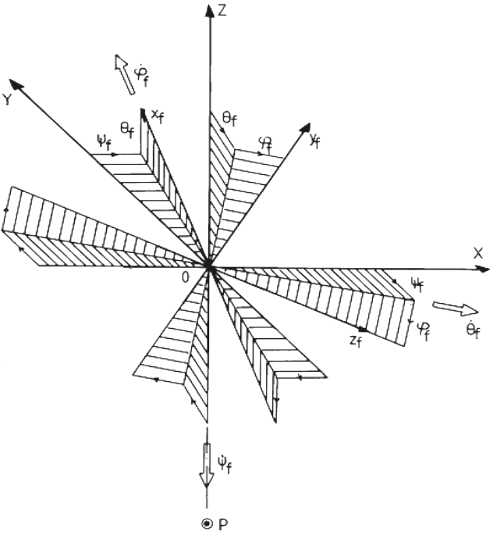

3. Rotation angles of Serret-Frenet axes, (Ox_{f} y_{f} z_{f} ), relative to Earth axes, (OXYZ)

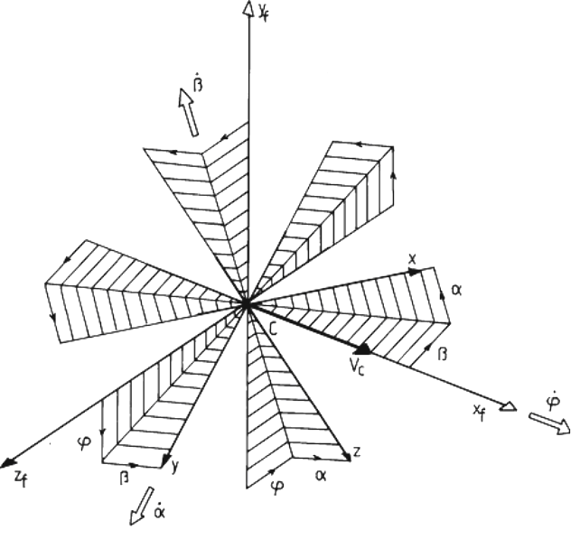

Senior Researcher INCAS-SA, Bucharest, Romania

