Hydrodynamic Pressure Acting on a Free Drop under Interfacial Tension Gradients
Ioan-Raducan Stan*, Maria Tomoaia-Cotisel* and Aurelia Stan**

*Babes-Bolyai University of Cluj-Napoca, Faculty of Chemistry and Chemical Engineering, Department of Physical Chemistry, Arany Janos Street, No. 11, 400026 Cluj- Napoca, Romania,
**County School Department of Cluj, Romania

Abstract
The movements of liquid drops resulting from unbalanced surface tension forces constitute an important surface phenomenon, known as the Marangoni effect. In our previous papers [4, 5, 6, 7] we have studied only the translation motion of the drop, generated by the hydrodynamic pressure, when a part or entire drop surface is covered with a surfactant [6, 7]. The aim of this paper is to correlate the effect of hydrodynamic pressure forces on the drop, with the surface coverage degree, namely on the extent to which the drop surface is covered with surfactant. Our calculations show that for a coverage degree less then 68⁰, these forces are negative, this means that the forces exerted by the external liquid upon the drop is oriented towards the negative direction of the normal to the drop surface. This force acts like a “hammer” generating the flow instability on the drop, first, as surface waves which can transfer, by viscosity, their energy to produce internal waves [8, 9]. These internal waves are similar with those sea weaves named tsunami. So, we suppose that the deformations, rotations and oscillations of a drop under interfacial tension gradients are due to these internal waves, excited by the Marangoni flow.

1. Introduction
A drop submerged in an immiscible liquid, initially motionless, being at neutral buoyancy or at zero gravity is called free. The application of an interfacial tension gradient on the drop surface can cause various motions of the free drop in a liquid. The desired tension gradient can be introduced in many ways. One of them, the subject of the present work, is caused by surface active compounds. The experimental work [1-3] showed that surfactants, adsorbed on a free drop, lead to complicate movements of the drop.
Much attention was given to the translational movement [1-6] of the drop, which is thought as a direct consequence of the surface flow (the Marangoni effect), which in turn is caused by the interfacial tension gradients. To study the translational movements we considered only not deformable free drops. Previously, we showed, in a direct experimental way, that at small interfacial tension gradients and large viscosities, the drop behaves as being practically not deformable [5]. The use of undeformable free drops and colored surfactants, allowed us to show, filming with a high-speed camera, the existence of a real surface flow on the drop. The spreading of the surfactant on the drop surface takes place with a distinct front dividing the drop surface into two regions, one covered (colored) and the other uncovered with surfactant molecules.
As a result of the surface flow, which causes the motion of the neighboring liquids by viscous traction, forces of hydrodynamic pressure will appear and act on the drop surface. Due to the symmetry, the resultant F_{p} of the forces, exerted by the surface flow on the drop, have the application point in the injecting point of the drop, with surfactant. These pressure forces determine all the drop movements, especially deformations, rotations and oscillations of the whole drop, as well as surface waves and the translational motions.
In our previous papers [4-7] we have studied only the translational motions of the drop, generated by the resultant forces F_{p}, after a substantial part of the drop surface is covered with surfactant.
The aim of this paper is to correlate the effect of pressure forces on the drop, with the surface covering degree, namely with the extent to which the drop surface is covered with surfactant. Our calculations show that for a covering degree less then  68⁰ the resultant force F_{p} is negative. This means that the forces exerted by the external liquid upon the drop are oriented towards the negative direction of the normal to the drop surface. This force acts like a “hammer” which generates a shear-flow instability on the drop. This shear first generates surface waves which can transfer, by viscosities, their energy to the drop liquid producing internal waves [8,9]. These internal waves are similar with those of the sea waves named tsunami. So, we suppose that all deformations and oscillations of the drop under tension-active gradients are due to these internal waves, generated by the Marangoni effect.

2. Hydrodynamic and Mathematical Model.
Here we report the generation and evolution of the hydrodynamic pressure which appears during the adsorption of a surfactant by a motionless drop.
To give a theoretical formulation of the surface flow it will be considered a drop L’, suspended in an immiscible liquid L. The force $\vec{F}$acting on the unit volume of the drop
$\vec{F}=(\text{ρ-ρ})\text{ \{}\vec{g}=0$ (1)
will be cancelled, either when the densities of the two liquids are equal (ρ’=ρ) or in the absence of gravity $\bar{g}$=0. Such a drop is called “free” and is motionless.
The theoretical model presented here considers that:
- the drop is initially at rest;
- a radial surface-tension gradient is established;
- a real radial surface flow (called Marangoni flow) arises on the drop surface, with a distinct front, and advances continuously;
- no surfactant transfer from the drop surface, inside or outside of the drop, is considered;
- bulk, drop and surface liquids are thought Newtonian, viscous and incompressible;
- the Reynolds number is assumed small, less than unity;
- the radial surface- tension gradients lead only to the mechanical instability.
It is supposed that the initial surface tension is σ₀. In a point on the drop surface, the interfacial tension is lowered to σ₁, by injecting a surfactant (a little droplet small compared with the drop 10⁻³-10⁻² cm³) in a well-chosen point. A radial interfacial tension gradient (Π = σ₀-σ₁) appears and, as an immediate consequence, the Marangoni spreading of the surfactant is initiated [5]. Local variations of the temperature, of the electric charge or surface chemical reactions may produce a similar effect.
The symmetry of the problem suggests a system of spherical coordinates (r, θ, φ) with the origin placed in the drop center and with the Oz axis passing through the sphere in the point of the minimum interfacial tension, i. e. the injecting point of the surfactant. We underline that the injecting point of the surfactant on the drop surface may be taken anywhere, the drop being initially at rest. We shall take it like in figure 1.
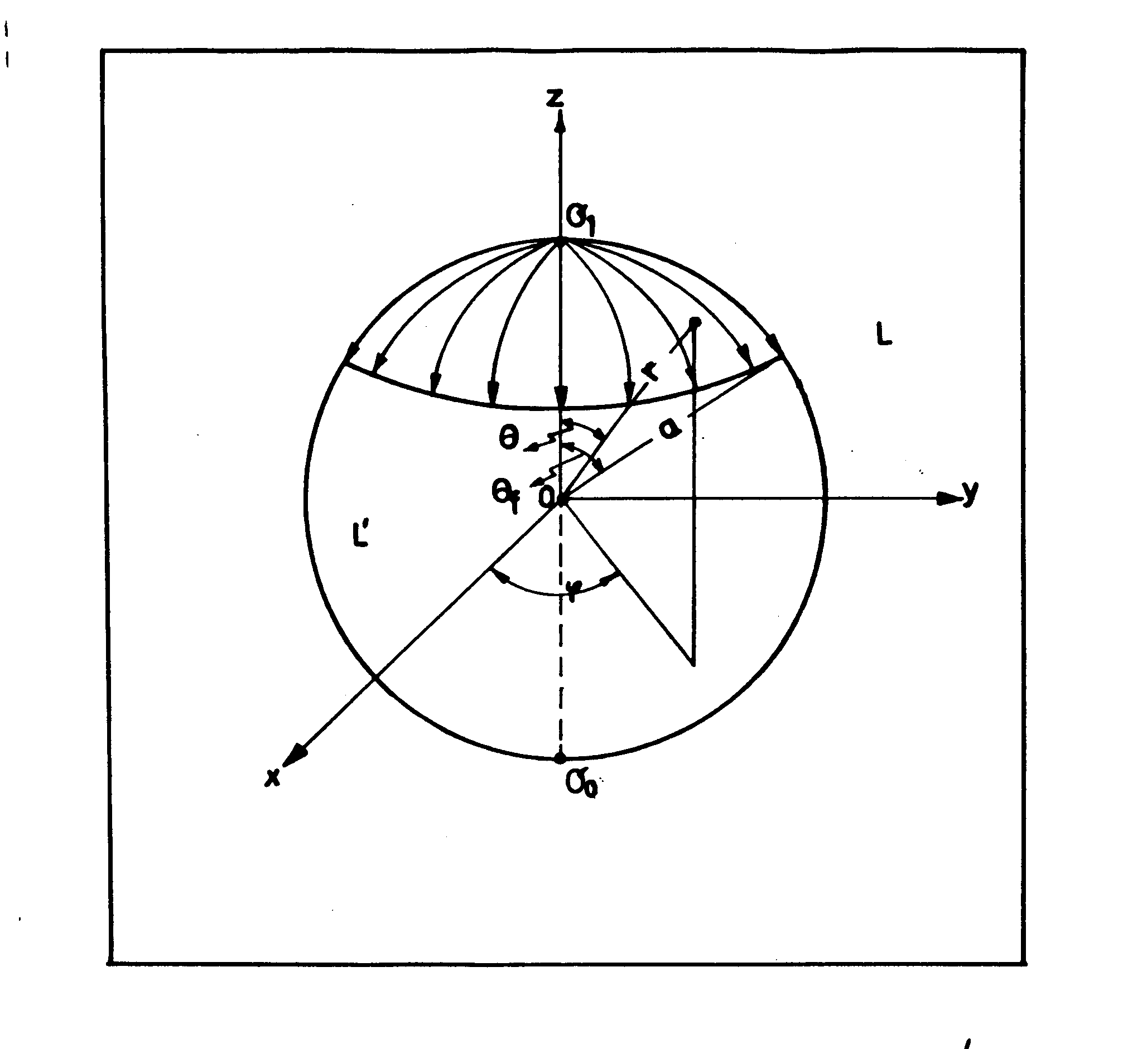

Figure 1. The system of spherical coordinates.

The surfactant front position in this radial flow, is noted by the angle θ_{f}. The interfacial tension σ is a unique function of angle θ. Inside of the invaded region (0$θ≤θ_{f}$), for the variation of the interfacial tension with θ, we have [7]:
$σ(θ) =\frac{σ_{o}−σ_{1}}{1−\text{cos}θ_{f}}(1−\text{cos}θ)+σ_{1}, \text{where }σ_{0}=σ(θ_{f}) \text{and }σ_{1}=σ(0),$ (2)
By derivation of Eq. (2), we get the interfacial tension gradient in the invaded region with surfactant given by the following equation:
$\frac{\text{dσ}}{\text{dθ}}=\frac{σ_{0}−σ_{1}}{1−\text{cos}θ_{f}}\text{sin}θ$. (3)
where, the interfacial tension σ₀ is constant in any point of the uncovered surface, while the interfacial difference $σ_{0}−σ_{1}$ arises only in the invaded region. It is evident that only σ₁ and σ_{0,} i. e. the minimum and the maximum values of the interfacial tension, can be experimentally measured.

3. The Hydrodynamic Equations and the Boundary Conditions
The equations governing the flow inside and outside the drop are the continuity and Navier-Stokes equations [10, 11]. The continuity equations are
div $\vec{v}=0$, (4)
div $\vec{v}'=0$ (5)
where $\vec{v}$is the velocity of the bulk L liquid and $\vec{v}$’ is the velocity of the L’ liquid within the drop.
$\text{The Navier-Stokes equations for a steady flow are: }$
$(\vec{v}⋅∇)\vec{v}=−\frac{1}{ρ} \text{grad p }+\text{ ν }Δ\vec{v}$ (6)
$(v' ⋅∇)v'=−\frac{1}{ρ}\text{grad p' }+\text{ ν' }Δv'$ (7)

where p and p’ are the pressure outside and inside of the drop, $ν=\frac{μ}{ρ}$ and $ν '=\frac{μ '}{ρ}$ are the bulk and the drop kinematic and dynamic viscosities, respectively, considered constants.
The drop surface is considered a two dimensional, incompressible Newtonian fluid, so that the equation of the interface flow is [12-14]
$\begin{aligned} \\ Γ(\vec{w}⋅∇)\vec{w}=\vec{F}+∇_{s}σ+(κ+ε)∇_{S}(∇_{S}⋅\vec{w})\text{, }(8)\end{aligned}$
where $\vec{w}={\vec{v}}_{s}$ is the interface velocity, $\vec{F}=Γ \vec{g}+\vec{T}\text{- \{}\vec{T} '$ is the external force acting on the drop surface, $\vec{T}\text{ and \{}\vec{T} \text{' }$are the tractions exerted by the outer and inner liquid on the drop interface, Г is the surface density, κ and ε are the surface dilatational and shear viscosity, respectively, and $∇_{s}$ is the surface gradient operator. Because the surface density is very small (Г ≈ 10 ⁻⁷g. cm ⁻²) the inertial term can be neglected against the remainder terms.
In order to find the distributions of the velocities $\vec{v}\text{ and \{}\vec{v}\text{ '}$and of the pressures p and p’, the system of equations (4)-(8) must be solved taking into account some appropriate boundary conditions [10, 11].
The velocities of the inner and outer liquid of the drop must satisfy the following conditions:
- the outer velocity must be zero far from the drop surface,
$\vec{v}=\text{ 0 for r}→∞$(r being the distance from the drop centre to a point);
- the normal component of the outer and the inner velocities must be zero on the surface of the drop
${\vec{v}}_{n}={\vec{v}}_{n}^{'}=0$, at r = a;
- the tangential velocity components of the two liquids at the interface must be equals
${\vec{v}}_{t}={\vec{v}}_{t}^{'}$ at r = a;
- the velocity $\vec{v}$ within the drop must remain finite at all points, particularly at the centre of the drop ( r = 0 the origin of the coordinates).
Since the Marangoni flow on the surface of the drop r = a is symmetrical with respect
to the Oz axis (see figure 1), the velocities of the inner and outer liquid flows are not functions of the angle φ, they will have only normal (radial) and tangential components ${\text{ v}}_{r}(r,θ){\text{, v}}_{r}^{'}(\text{r, θ})\text{ ,} {\text{ v}}_{θ}(r,θ){\text{, v}}_{θ}^{'}(r, θ)\text{.}$
The continuity equation (4) for the outer flow in spherical coordinates is
$\frac{∂v_{r}}{∂ r}+\frac{1}{r}\frac{∂v_{θ}}{∂ θ}+\frac{{\text{2v}}_{r}}{r}+\frac{v_{θ}\text{ctq} θ}{r}=0$, (9)
while for the Navier-Stokes equation (6) we have
$\frac{∂ p}{∂ r}=μ\left(\frac{∂^{2}v_{r}}{∂ r^{2}}+\frac{1}{r^{2}}\frac{∂^{2}v_{r}}{∂ θ^{2}}+\frac{2}{r}\frac{∂v_{r}}{∂ r}+\frac{\text{ctg} θ}{r^{2}}\frac{∂v_{r}}{∂ θ}−\frac{2}{r^{2}}\frac{∂v_{θ}}{∂ θ}−\frac{{\text{2v}}_{r}}{r^{2}}−\frac{\text{2ctg} θ}{r^{2}}v_{θ}\right)$ , (10)
$\frac{1}{r}\frac{∂ p}{∂ θ}=μ\left(\frac{∂^{2}v_{θ}}{∂ r^{2}}+\frac{1}{r^{2}}\frac{∂^{2}v_{θ}}{∂ θ^{2}}+\frac{2}{r}\frac{∂v_{θ}}{∂ r}+\frac{\text{ctg} θ}{r^{2}}\frac{∂v_{θ}}{∂ θ}+\frac{2}{r^{2}}\frac{∂ v_{r}}{∂ θ}−\frac{v_{θ}}{r^{2}{\text{sin}}^{2}θ}\right)$ , (11)
and similar equations for the inner liquid motion.
The velocities of the inner and outer flow satisfy the following boundary conditions
${\text{ v}}_{r}=v_{θ}=0 \text{for r}→∞$, (12)
$v_{r}=v_{r}^{'}=\text{0 at r}=a$ (13)
$v_{θ}=v_{θ}^{'} \text{ at r}=a$, (14)
$v_{r}^{'} {\text{and v}}_{θ}^{'} \text{are} \text{finite} \text{at} r=0$. (15)
In addition to these kinematics conditions we have also a dynamic condition on the drop surface (r = a), obtained from the interface flow equation (8), which for small interface density Г can be written in the following form [13, 14]:

$μ{\left(\frac{1}{r}\frac{∂v_{r}}{∂ θ}+\frac{∂v_{θ}}{∂ r}−\frac{v_{θ}}{r}\right)}_{r=a}+\frac{1}{a}\frac{d σ}{d θ}+(κ+ε){\left[\frac{1}{r}\frac{∂}{∂ θ}\left\{\frac{1}{\text{rsin} θ}\frac{∂}{∂ θ}(v_{θ}\text{sin} θ)\right\}\right]}_{r=a}$
(16)
$+ε\frac{2(v_{θ})_{r=a}}{a^{2}}=\text{μ'}\left(\frac{1}{r}\frac{∂v_{r}^{'}}{∂ θ}+\frac{∂v_{θ}^{'}}{∂ r}−\frac{v_{θ}^{'}}{r}\right)$.

4. Pressure Force F_{p} Exerted on the Drop
The resultant F_{p} of the pressure forces exerted by the bulk liquid on the drop, due to the symmetry of the problem, is along the Oz axis and has the form [10]:

${\text{ F}}_{p}=\iint_{S}{(p_{\text{rr}}\text{cosθ}−p_{\text{rθ}}\text{sin})\text{ ds}}$, (17)
where, ds is the surface element, S the covered surface with surfactant, p_{rr} and p_{rθ} the normal and tangential components of the viscous stress tensor
$p_{\text{rr}}=−p+\text{2μ}\frac{∂ v_{r}}{∂ r}$ (18)
$p_{\text{rθ}}=μ\left(\frac{1}{r}\frac{∂v_{r}}{∂ θ}+\frac{∂v_{θ}}{∂ r}−\frac{v_{θ}}{r}\right)$ (19)
The surface element in spherical coordinates being, for r = a
$\text{ds}=2π a^{2}\text{sin}θ \text{dθ}$, (20)
the resultant forces acting on the drop (17), can than be rewritten as
$F_{p}=2π a^{2}\int_{0}^{θ_{f}}{(p_{\text{rr}}\text{cos} θ−p_{\text{rθ}}\text{sin} }θ) \text{sin} θ \text{dθ }\text{.}$ (21)
From Eqs. (10) and (11) with the boundary conditions (12)-(16), one obtain for the normal and tangential components of the stress tensor, at the drop surface (r = a):
$( p_{\text{rr}})_{r=a}=− \frac{A}{(1−\text{cos} θ_{f})}\text{co} θ ,$ (22)
$(p_{\text{rθ}})_{r=a}=− \frac{A}{(\text{1-cos} θ_{f})}\text{sin} \text{θ ,}$ (23) A being a constant
$A=\frac{μ (σ_{0}−σ_{1})}{a \left(μ+μ'+\frac{2κ}{3a}\right)}$ (24) depending on the radial surface tension gradient, П = σ₀ – σ₁, radius of the drop(a), volume viscosities (μ, μ’) and surface dilatational viscosity (κ). Introducing the viscosities ratio λ = μ’/μ [18] and because 2κ/3aμ ≈ 0 [5] we have for A the form:
$A=\frac{Π}{a(1+λ)}$ (25)
which depends only of the viscosities ratio λ, the drop radius a and the surface tension gradient П. Introducing the values of p_{rr} and p_{rθ} from Eqs. (22) and (23) into Eq. (21) we obtain after integration:
${\text{ F}}_{p}=\frac{2π \text{a }Π }{1+λ}(1−{\text{2cosθ}}_{f}−{\text{2cos}}^{2}θ_{f}),$ (26)
which is the resultant force F_{p} acting on the drop surface along the Oz axis. It can be seen that the resultant force F_{p} depends on the θ_{f} angle, namely, on the extent to which the drop surface is covered with surfactant. It depends also on the radial interfacial tension gradient П, the ratio of the volume viscosities (λ) as well as of the radius (a) of the drop.

5. Surfactant Surface Coverage and Its Effects on the Drop
For further discussions it is useful to introduce the function:
f(θ_{f}) = 1−2 cos θ_{f} −2 cos²θ_{f} (27)
and its graphic representation f(θ_{f}) vs. θ_{f} is given in figure 2.
The value of θ_{f}, for which f(θ_{f}) = 0, is noted by θ₀ and its value is θ₀ =68⁰.531; this means the value of θ_{f} for which the force F_{p} cancels. This value of θ₀ doesn’t depend on the physical chemistry and geometric properties of the drop. We see that for${\text{ θ}}_{f}∈[0, θ_{0})$, this function is negative f(θ_{f}) <0, and for$θ_{f}∈( θ_{0}\text{, }{\text{180}}^{0}]$ the function is positive f(θ_{f})>0, having the greatest value for θ_{m} = 120⁰.

From Equation (26) it is found that for a coverage degree $θ_{f}<θ_{0}$of the drop, with surfactant, as a result of the appearance of a radial interfacial tension gradient П, the pressure force F_{p} exerted by the external liquid upon the drop is oriented toward the negative direction of the Oz axis (Figure 3a). This is similar with the application of a “hammer” knock on the drop in the injecting point of the surfactant. For a coverage degree θ_{f} greater than θ₀, but less than 180⁰, the force F_{p} is oriented towards the positive direction of the Oz axis (Figure 3b). The propulsive (lifting) force F_{p} >0, responsible for the upward movement of the drop, appears only when the coverage of the drop with surfactant is greater than θ₀.

(a) (b)
Figure 3.
a) Hammer effect b) Propulsive force

For different radial surface tension gradients П (density, viscosity and the radius of the drop supposed to be constant) the hydrodynamic force F_{p} have different values. To point out the role of the surface tension gradients П on the force F_{p} we introduce, from Equation (26), a new function $Φ_{Π}=Πf(θ_{f})$which is a reduced hydrodynamic force. Its graphic representation $Φ_{Π}$ versus $θ_{f}$ for various values of Π (Π = 0.5; 1; 2; 4; 5 dyn/cm) is given in figure 4.

The effect of coverage with surfactant on the drop surface can be decomposed in two parts:
- the “hammer” effect for the coverage 0 ≤ θ_{f} < θ₀ and
- the “propulsive “ effect for the coverage θ₀ <θ_{f} ≤180⁰ shown in figures 3 and 4.

In the following, we investigate the effects of different surface tension gradients in the first case${\text{ θ}}_{f} <θ_{0}$(see figure 5). From figure 5, it is observed that for high radial surface tension gradients (4 dyn/cm and 5 dyn/cm) the “hammer” effect is also high. For low surface tension gradients (e.g. 0.5 dyn/cm; 1 dyn/cm; 2 dyn/cm), this hammer effect is small. This result is in good agreement with our previous work [5], where the main goal was to maintain the drop non-deformable using high viscosity liquids and small surface tension gradients (≈ 2.5 dyn/cm).
An important observation is that the actions of the force F_{p} is maximum at the spreading moment of the surfactant for which θ_{f} ≈ 0, and tends to zero as the coverage with surfactant reaches θ₀ value.

Previously, we have shown that for low surface tension gradients and high drop viscosity, when the drop is not deformable, for θ_{f} ≤ θ₀, no hammer effect is observable [5]. However, when the drop is deformable (i.e. for high surface tension gradients and low drop viscosity), for θ_{f} ≤ θ₀, hammer effect was observable [5]. The drop deformation is maxim at the spreading moment and after a short recorded time from 0.8 to 1.2 seconds the drop takes its initial shape.

5. Concluding Remarks.
The general assumption, that for small surface tension gradients, the drop is not deformable, seems to be too restrictive. In fact, there are other movements, first of all, surface waves are produced by the hammer effect (figure 5), which generate a surface Marangoni instability of the drop [8]. Then, internal waves are excited by these surface waves, which had been generated by the surface tension gradients. As a consequence, traveling periodic internal wave trains are generated in the liquid drop after the adsorption/spreading of the surface-active compound/surfactant.
Internal waves are observed in many geophysical systems like ocean currents, the atmosphere or magma flows. They are usually generated by a shear-flow instability in the bulk. Internal waves can also be generated in an initially motionless fluid by surface shear. The shear, for example, could be produced by a wind blowing over the surface that first generates surface waves. Then, these surface waves can transfer their energy to the internal waves.
An analogue process takes place also at the surface of a drop, under a radial interfacial gradient. The pressure F_{p} force which acts on the drop corresponding to F_{p} < 0 first generates surface waves. Then these surface waves can transfer their energy to the internal waves in the drop.
Two possibilities can occur for the hammer effect (θ_{f} ≤ θ₀):
- The drop viscosity μ’ is large, then, the energy of the traveling periodic internal trains of waves are absorbed by the drop liquid and the drop is not deformable. Nevertheless, other movements might appear, like oscillations of the whole drop, rotations. etc.
- The drop viscosity μ’ is small and the energy of the internal waves is not absorbed and they will be reflected by the internal drop surface. The superimposing of the direct internal waves with the reflected ones, give rise to a “resonant” effect, which generate the deformation and even fission of the drop.
Our model relies on mechanical interpretation of the deformation of a drop, as the effect due to a reduction of the drop interfacial tension at the injection point with surfactant. There are more mechanisms through which surfactants can change the drop deformations, but these are consequences of the Marangoni surface instability of the drop [15-17]. For example, the increase of the surface area of a drop, when it is deformed to a no spherical shape, dilutes the surfactant surface concentration, which in turn, will increase the interfacial tension and decreases the drop deformation. This is called the surface dilution effect. But, we mention again, that this dilution effect appears only after the drop is deformed as o consequence of the Marangoni instability, due to existence of the radial surface tension gradients.
The propulsive force, F_{p} >0, responsible for the translational movement (figures 3b and 4) of the drop appears only when the coverage of the drop with surfactant is greater than θ₀ ≈ 68⁰.
References

- R. S. Valentine, W. J. Heideger, Ind. Eng. Chem. Fundamentals, 2, 242 (1963)
- R. S. Valentine, N. F. Sather, W. J. Heideger, Chem. Eng. Sci. , 20, 719 (1965)
- E. Chifu, I. Stan, Rev. Roum. Chim., 25, 1449 (1980)
- I. Stan, Z.Finta, E.Gavrila, Rev. Chim., 8, 765 (1980)
- E.Chifu, I. Stan, Z.Finta, E. Gavrila , J.Colloid Interface Sci., 93, 140, (1983)
- I. Stan, E. Chifu, Z. Finta, E. Gavrila, Rev. Roum. Chim., 2, 603 (1989)
- I. Stan, C. Gheorghiu, Z. Kasa, Studia Univ. Babes- Bolyai, Math., 2, 113 (1993)
- A. Wierschem, H. Linde, M. G. Velarde, Phys. Rev., 42, 5 (2000)
- A. Ye. Rednikov, P. Colinet, M.G. Velarde, J. C. Legros, J. Fluid Mech. 405, 57, (2000)
- L. Landau, E. Lifschitz, “Mechanique des fluids”, Ed. Mir, Moscou (1971)
- V. G. Levici, “Physicochemical Hydrodynamic”, Prentice-Hall, New York (1962)
- L. E. Scriven, Chem. Eng. Sci., 12, 98 (1960)
- R. Aris, Vectors, “Tensors and the Basic Equations of Fluid Mechanics”, Prentice-Hall, New York (1962)
- A. Sanfeld, in Physical Chemistry Series, Academic Press, New York , 1, 248 (1971)
- W. I. Miliken, H. A. Stone, L. G. Leal, Phys. Fluids A5, 69 (1993)
- Y. Pawar, K. J. Stebe, Phys. Fluids A8, 1738 (1996)
- C. D. Eggleton, Y. P. Pawar, K. J. Stege, J. Fluid Mech., 385, 79 (1999)
- Y. T. Hu, A.Lips, Phys. Rev. Letter, 91, 1(2003).

